ARCHITECT REVIEW
SCC-4179 | Restrict CPNI Field Access
Great Plains sandboxes | Read-only least-privilege readiness assessment
Environments | GreatPlainsMerge 00DEa00000GkAsHMAV | GreatPlainsUAT 00DEa00000FZlLBMA1
Review date | 26 August 2026
Evidence | SOQL read-back | FieldPermissions and PermissionSetAssignment
Decision | Changes Requested - not ready for promotion
Boundary | No records, assignments, metadata, deployment, activation, or Production changes

ARCHITECT DECISION
Do not promote yet. The approved CPNI permission set is correct, but profile and broad permission-set grants still expose both fields, so permission-set-only access is not achieved.

Acceptance outcome
# | Scope | Result | Evidence
1 | Named profiles | Fail | System Administrator, API Only, and Standard User still grant read and/or edit in both sandboxes.
2 | Other profiles | Fail | UAT also exposes both fields through Product, GPC-BI & Reporting, and GPC-Residential CRC Team.
3 | Non-target permission sets | Fail | Account and Contact - Full Access and Heroku and Data Hub Permissions retain read access.
4 | Approved permission set | Pass | Contact Encrypted CPNI Read/Write Access grants read/edit to both fields in Merge and UAT.
5 | Production and runtime proof | Not run | Production was not inventoried and no named-user UI/API UAT or deployment was performed.

Solution and control path
The solution is declarative FLS: remove both CPNI fields from every profile and non-approved permission set, retain read/edit only in the approved permission set, then prove exclusivity with named users and permission read-back.
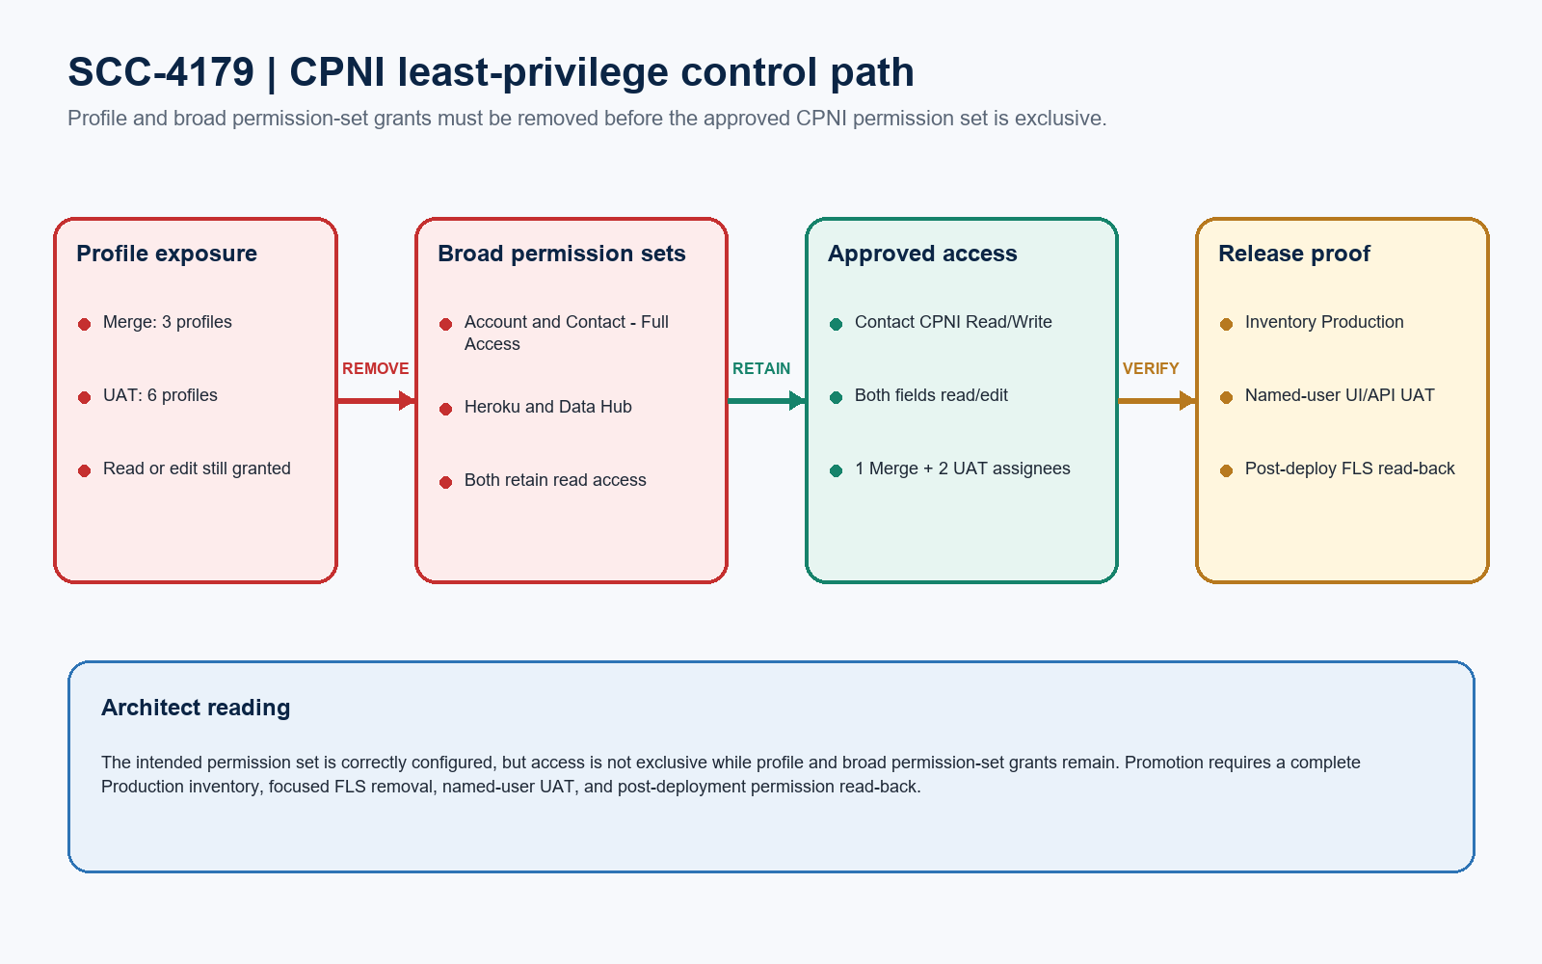
Figure 1. SCC-4179 CPNI least-privilege control path
DESIGN READING
Green is the intended grant. Red access paths must be removed. Amber is the release evidence gate before promotion.

Current CPNI access evidence

GreatPlainsMerge
Access path | CPNI Password | CPNI Pin | Acceptance
System Administrator | Read | Read / Edit | Fail
System Administrator - API Only | Read / Edit | Read / Edit | Fail
Standard User | Read | Read | Fail
Account and Contact - Full Access | Read | Read | Fail
Heroku and Data Hub Permissions | Read | Read | Fail
Contact Encrypted CPNI Read/Write Access | Read / Edit | Read / Edit | Pass - 1 assignment

GreatPlainsUAT
Access path | CPNI Password | CPNI Pin | Acceptance
System Administrator + API Only | Read / Edit | Read / Edit | Fail - 2 profiles
Standard, Product, GPC-BI, GPC-Residential | Read | Read | Fail - 4 profiles
Account and Contact - Full Access | Read | Read | Fail - grant path
Heroku and Data Hub Permissions | Read | Read | Fail - 1 assignment
Contact Encrypted CPNI Read/Write Access | Read / Edit | Read / Edit | Pass - 2 assignments

EXCLUSIVITY BLOCKER
The target permission set works, but it is not the only grant path. Every profile and non-target permission set must lose both read and edit before SCC-4179 can pass.

Implementation and release boundary
Component type | Focused scope | Required action
Contact fields | CPNI_Pin__c; CPNI_Password__c | Reference only - no schema change
Named profiles | System Administrator; API Only; Standard User | Remove read and edit for both fields
Additional UAT profiles | Product; GPC-BI & Reporting; GPC-Residential CRC Team | Remove read access; inventory Production equivalents
Broad permission sets | Account_and_Contact_Full_Access; Heroku_and_Data_Hub_Permissions | Remove both field grants
Approved permission set | Contact_CPNI_Read_Write_Access | Preserve read=true and edit=true
Code and automation | Apex, Flow, validation rules, layouts | No change

Release sequence
Phase | Required evidence
Pre-deployment | Retrieve Production FLS; inventory all grant paths and target-set assignees; assess integrations; run focused check-only validation; obtain Security and release approval.
Deployment | Promote only approved FLS removals to UAT first; retain the target permission set; deploy to Production only after named-user UAT and an approved change window.
Post-deployment | Read back FieldPermissions and assignments; run negative and positive UI/API tests; review Setup Audit Trail; capture job ID, scope, results, and sign-offs.
Rollback | Restore the approved metadata backup only if a critical dependency fails; remove any temporary emergency permission assignment after resolution.

PRODUCTION GATE
Do not use the sandbox component list as a complete Production package. Production was not inspected; its full FLS and assignment inventory is mandatory before validation or deployment.

UAT and approval gates
Test | Pass evidence
Negative UI | Named users without the target set cannot see either field on View or Edit.
Negative API | The same users cannot query or update either field through the approved API test path.
Positive access | A named user with only the target set can view and edit both fields using synthetic UAT data.
Exclusivity | FieldPermissions read-back shows the target permission set as the only remaining read/edit grant path.
Regression | Approved integration and reporting owners confirm expected behavior after profile and broad-set removal.

Required approval gates
# | Required action | Owner | Evidence needed
1 | Inventory Production | Salesforce Admin / Security | Complete profile, permission-set, assignment, integration, and reporting impact inventory.
2 | Approve authorized users | Data Owner / Security | Final target-permission-set assignee list and emergency-access process.
3 | Validate focused package | Release Manager | Check-only job ID, exact components, test result, and explicit deployment approval.
4 | Run named-user UAT | QA / Business Owner | UI/API negative and positive tests with record IDs, timestamps, and screenshots.
5 | Promote and read back | DevOps / Salesforce Admin | Deployment receipt, FLS/assignment read-back, audit trail, and sign-offs.

Ready-to-paste architect response
STORY COMMENT
Architect review completed for SCC-4179 in GreatPlainsMerge and GreatPlainsUAT. Changes Requested: Contact_CPNI_Read_Write_Access correctly grants read/edit to CPNI Pin and CPNI Password, but permission-set-only access is not achieved. Merge still grants access through three profiles and two broad permission sets; UAT grants access through six profiles and two broad permission-set definitions. Production was not inspected. Complete the Production inventory, remove both field grants from every profile and non-target permission set, retain the approved permission set, run focused check-only validation and named-user UI/API UAT, then capture post-deployment FLS and assignment read-back. No records, assignments, metadata, activation, deployment, or Production changes were made during this review.

